`

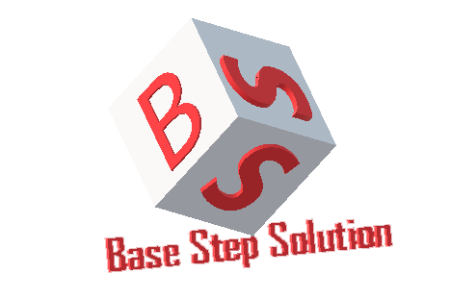

Meeting Minutes

Van Lang Admissions

# Revision Table

|  |  |  |  |
| --- | --- | --- | --- |
| **Author** | **Date** | **Reason for changes** | **Version** |
| Khoi Nguyen | 02/03/2017 | Initial Document | 1.0 |

Table of Contents

Revision Table 1

I. Purpose 3

II. Participant in meeting 3

III. Content of meeting 3

IV. To do task 4

|  |  |  |  |  |  |
| --- | --- | --- | --- | --- | --- |
| **Writer:** | Khởi Nguyễn | **Location:** | Floor 9, Etown 2 | | |
| **Date:** | 02/03/2017 | **Start:** | 19h | **Finish:** | 22h |

# Purpose

* Discuss about Architecture Design
* Demo elastic search

# participant in meeting

Mentor : Vũ Thế Nam

Team Capston:

* Nguyễn Thái Hiền
* Nguyễn Hoàng Anh Tài
* Đoàn Anh Minh
* Trần Xuân Hải
* Nguyễn Xuân Thái Hiền

# Content of meeting

* Recombined into a server or not?
* Cache can consume more RAM
* Split database to distinguish MongoDB, Redis, Elastic, Image
* Demonstrate your Physical meet the needs of customers
* Demo sync data from MongoDB – Elastic Search
* What functions should use Redis, Elastic Search
* Close function Create Examination
* Drawing Static, Dynamic must clearly show which is located
* Differentiate between Static & Dynamic View
* Dynamic drawing splits 1 client & 1 server
* There will be keyword for question list, 2 fields answered - not yet answered
* App on mobile

# To do task

* Complete architecture design

---- *** ----